|  |  |
| --- | --- |
|  | SOFTWARE DEFINED NETWORKING  Lab 2: Use Mininet with MiniEdit GUI |

Nhóm học phần:

1) Mã Sinh viên, Họ và Tên

2)

3)

MỤC LỤC

1. Overview 1

2. Objectives 1

3. Build and emulate a network in Mininet using the GUI 2

3.1. Method 1: Run MiniEdit GUI from MobaXterm 2

3.2. Method 2: Run the Remote Desktop Connection program from your computer. 2

3.3. Build the network topology 3

3.4. Test connectivity 6

3.5. Automatic assignment of IP addresses 9

3.6. Save and load a Mininet topology 11

4. Configure router r1 13

4.1.1. Verify end-hosts configuration 14

4.1.2. Configure router’s interface 15

4.1.3. Verify router r1 configuration 19

4.1.4. Test connectivity between end-hosts 20

5. References 21

*>> Yêu cầu chụp hình ảnh là kết quả thực hành của SV. Không sử dụng lại hình ảnh của bài lab.*

# Overview

This lab provides an introduction to Mininet, a virtual testbed used for testing network tools and protocols. It demonstrates how to invoke Mininet from the command-line interface (CLI) utility and how to build and emulate topologies using a graphical user interface (GUI) application.

# Objectives

By the end of this lab, students should be able to:

1. Understand what Mininet is and why it is useful for testing network topologies.
2. Invoke Mininet from the CLI.
3. Construct network topologies using the GUI.
4. Save/load Mininet topologies using the GUI.
5. Configure the interfaces of a router using the CLI.

# Build and emulate a network in Mininet using the GUI

## Method 1: Run MiniEdit GUI from MobaXterm

Run MobaXterm: Choose [Sessions]/[New session][SSH]

Remote host: wandertour.ddns.net

Username: masv Port: 16

From the command prompt, type the following command:

$ sudo cp -r /mininet $HOME/.

$ sudo -E python ./mininet/examples/miniedit.py

## Method 2: Run the Remote Desktop Connection program from your computer.

wandertour.ddns.net:3316

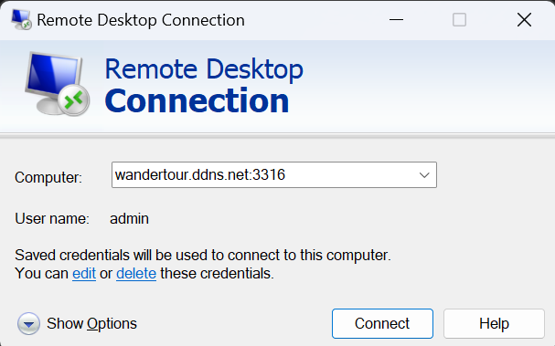

Open a terminal windows, type the following command:

$ cd

$ sudo cp -r /mininet $HOME/.

$ sudo -E python ./mininet/examples/miniedit.py

MiniEdit is a simple GUI network editor for Mininet.

## Build the network topology

**Step 1.** MiniEdit will start, as illustrated below.

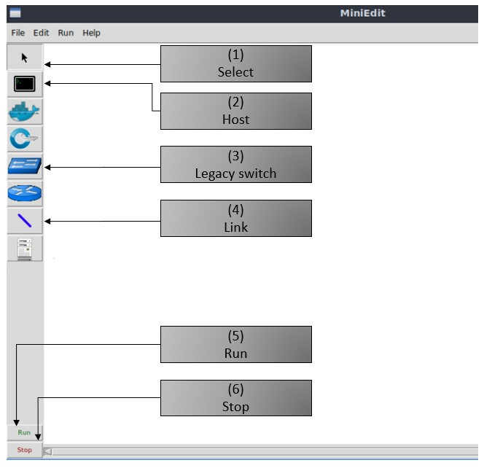

Figure 14. MiniEdit Graphical User Interface (GUI).

The main buttons in this lab are:

1. *Select*: allows selection/movement of the devices. Pressing *Del* on the keyboard after selecting the device removes it from the topology.
2. *Host*: allows addition of a new host to the topology. After clicking this button, click anywhere in the blank canvas to insert a new host.
3. *Legacy switch*: allows addition of a new legacy switch to the topology. After clicking this button, click anywhere in the blank canvas to insert the switch.
4. *Link*: connects devices in the topology (mainly switches and hosts). After clicking this button, click on a device and drag to the second device to which the link is to be established.
5. *Run*: starts the emulation. After designing and configuring the topology, click the run button.
6. *Stop*: stops the emulation.

**Step 2.** To build the topology illustrated in Figure 12, two hosts and one switch must be deployed. Deploy these devices in MiniEdit, as shown below.

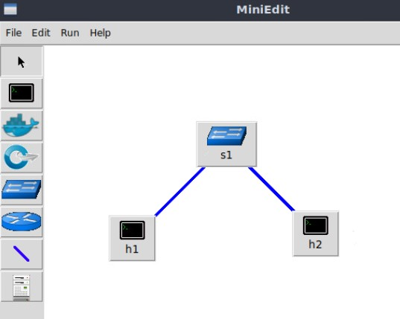

Figure 1. MiniEdit’s topology.

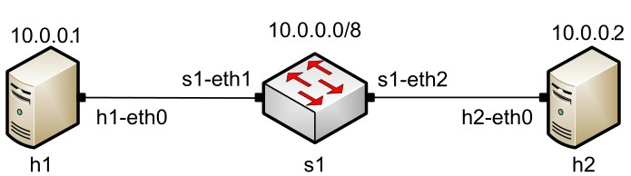

Figure 2. Lab topology.

Use the buttons described in the previous step to add and connect devices. The configuration of IP addresses is described in Step 3.

**Step 3.** Configure the IP addresses of host h1 and host h2. Host h1’s IP address is 10.0.0.1/8 and host h2’s IP address is 10.0.0.2/8. A host can be configured by holding the right click and selecting properties on the device. For example, host h2 is assigned the IP address 10.0.0.2/8 in the figure below.

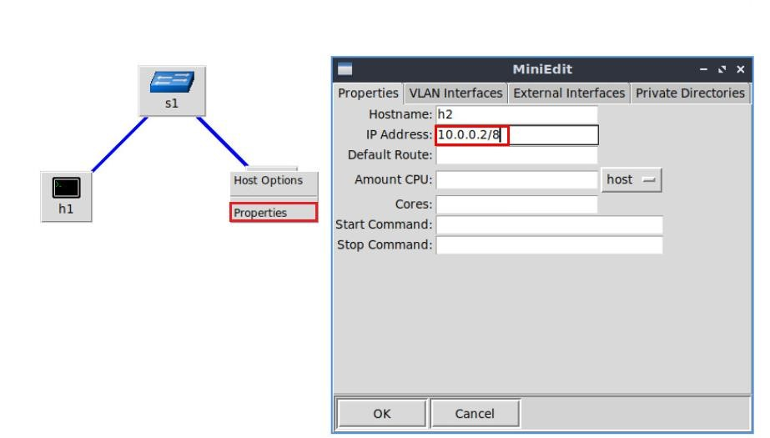

Figure 16. Configuration of a host’s properties.

## Test connectivity

Before testing the connection between host *h1* and host h2, the emulation must be started.

**Step 1.** Click on the *Run* button to start the emulation. The emulation will start and the buttons of the MiniEdit panel will gray out, indicating that they are currently disabled.

**Step 2.** Open a terminal on host *h1* by holding the right click on host h1 and selecting *Terminal*. This opens a terminal on host *h1* and allows the execution of commands on the host *h1*. Repeat the procedure on host *h2*.

The network and terminals at host h1 and host h2 will be available for testing.

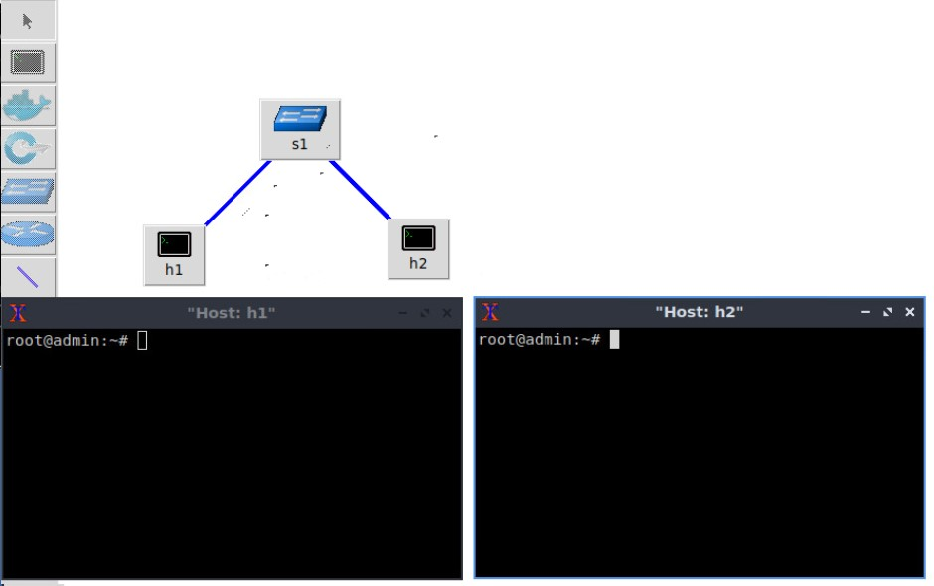

Figure 19. Terminals at host h1 and host h2.

**Step 3**. On host h1’s terminal, type the command shown below to display its assigned IP addresses. The interface *h1-eth0* at host *h1* should be configured with the IP address *10.0.0.1* and subnet mask *255.0.0.0*

root@admin# ifconfig

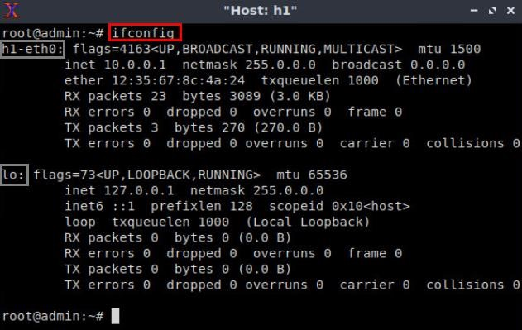

Figure 20. Output of command on host h1.

Repeat Step 3 on host h2. Its interface *h2-eth0* should be configured with IP address 10.0.0.2 and subnet mask 255.0.0.0.

**Step 4**. On host h1’s terminal, type the command shown below. This command tests the connectivity between host h1 and host h2. To stop the test, press Ctrl + c. The figure below shows a successful connectivity test. Host h1 (10.0.0.1) sent six packets to host h2 (10.0.0.2) and successfully received the expected responses.

root@admin:# ping 10.0.0.2

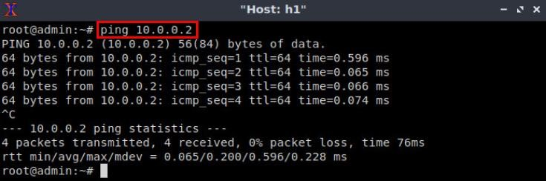

Figure 21. Connectivity test using command.

**Step 5**. Stop the emulation by clicking on the *Stop* button.

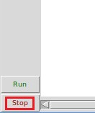

Figure 22. Stopping the emulation.

## Automatic assignment of IP addresses

In the previous section, you manually assigned IP addresses to host h1 and host h2. An alternative is to rely on Mininet for an automatic assignment of IP addresses (by default, Mininet uses automatic assignment), which is described in this section.

**Step 1.** Remove the manually assigned IP address from host h1. Hold right-click on host h1, *Properties*. Delete the IP address, leaving it unassigned, and press the *OK* button as shown below. Repeat the procedure on host h2.

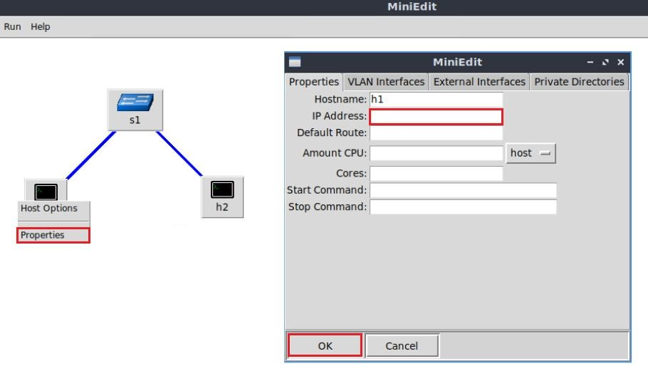

Figure 23. Host h1 properties.

**Step 2**. Click on *Edit*, *Preferences* button. The default IP base is 10.0.0.0/8. Modify this value to 15.0.0.0/8, and then press the *OK* button.

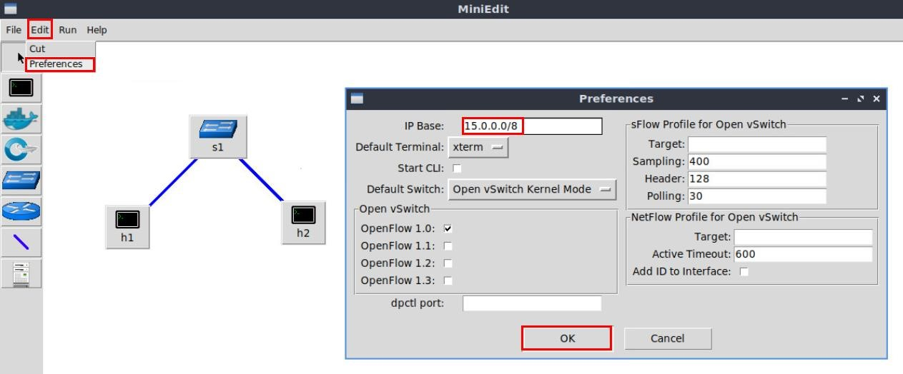

Figure 24. Modification of the IP Base (network address and prefix length).

**Step 3**. Run the emulation again by clicking on the *Run* button. The emulation will start and the buttons of the MiniEdit panel will be disabled.

**Step 4.** Open a terminal on host h1 by holding the right click on host h1 and selecting Terminal.

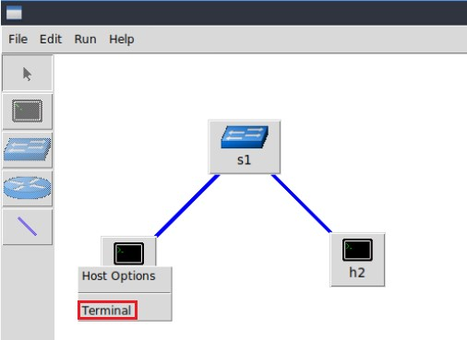

Figure 25. Opening a terminal on host h1.

**Step 5**. Type the command shown below to display the IP addresses assigned to host h1. The interface *h1-eth0* at host h1 now has the IP address 15.0.0.1 and subnet mask 255.0.0.0.

root@admin# ifconfig

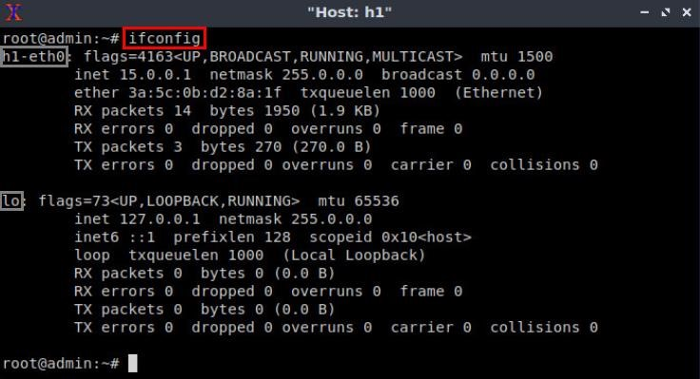

Figure 26. Output of command on host h1.

You can also verify the IP address assigned to host h2 by repeating Steps 4 and 5 on host h2’s terminal. The corresponding interface *h2-eth0* at host h2 has now the IP address 15.0.0.2 and subnet mask 255.0.0.0.

**Step 6**. Stop the emulation by clicking on *Stop* button.



Figure 27. Stopping the emulation.

## Save and load a Mininet topology

**Step 1.** Save the current topology by clicking on *File* then *Save*. Provide a name for the topology and save it in the local folder. In this case, we used *myTopology* as the topology name.

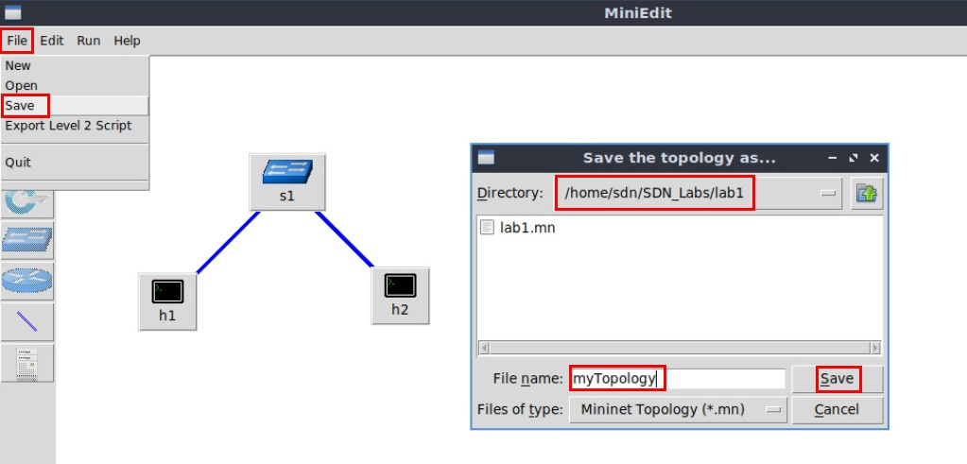

Figure 28. Saving the topology.

**Step 2.** Load the topology by clicking on *File* then *Open*. Search for the topology file called *lab1.mn* and click on *Open*. A new topology will be loaded to MiniEdit.

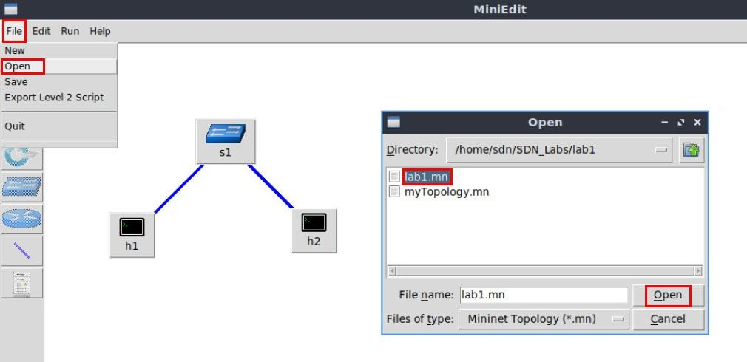

Figure 29. Opening a topology.

## Export mininet topology to python program

* Choose menu [File]/Export Level 2 Script]
* Give the name of python file: lab01.py
* Close MiniEdit
* From the command of Ubuntu, type;

$ nano lab01.py

$ sudo mn –custom lab01.py

# Configure router r1

Consider Figure 30. In this topology two LANs, defined by switch s1 and switch s2 are connected to router r1. Initially, host h1 and host h2 do not have connectivity, thus you will configure router r1’s interfaces to establish connectivity between the two networks.

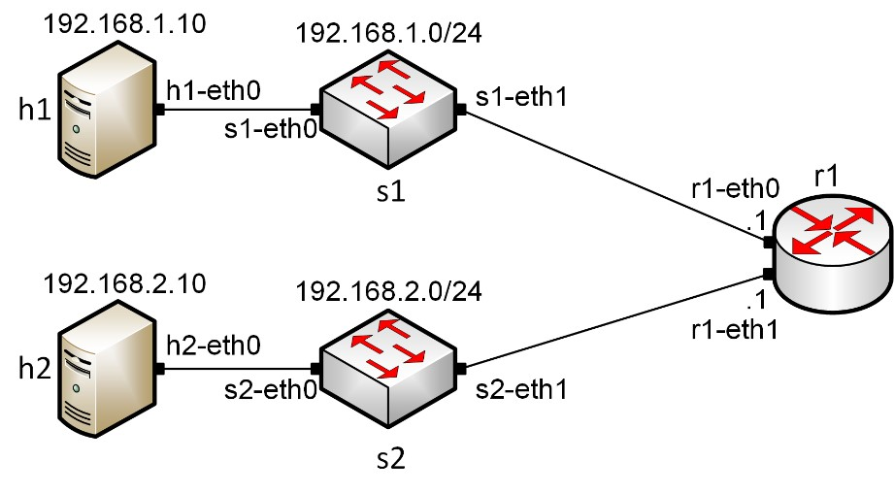

Figure 30. Topology.

Table 2 summarized the IP addresses used to configure router r1 and the end-hosts.

Table 2**.** Topology information.

|  |  |  |  |  |
| --- | --- | --- | --- | --- |
| **Device** | **Interface** | **IIP Address** | **Subnet** | **Default gateway** |
| r1 | r1-eth0 | 192.168.1.1 | /24 | N/A |
| r1-eth1 | 192.168.2.1 | /24 | N/A |
| h1 | h1-eth0 | 192.168.1.10 | /24 | 192.168.1.1 |
| h2 | h2-eth0 | 192.168.2.10 | /24 | 192.168.2.1 |

$ sudo -E python ./mininet/examples/miniedit.py

**Step 1.** Click on the *Run* button to start the emulation. The emulation will start and the buttons of the MiniEdit panel will gray out, indicating that they are currently disabled.

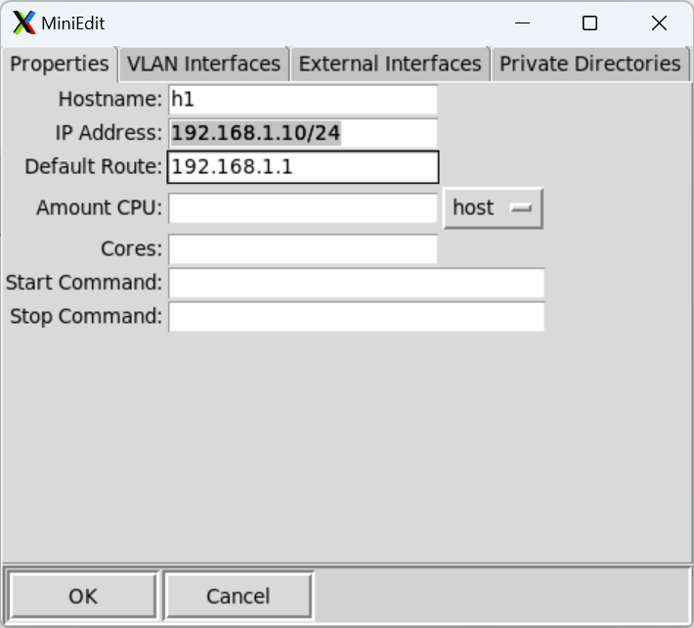

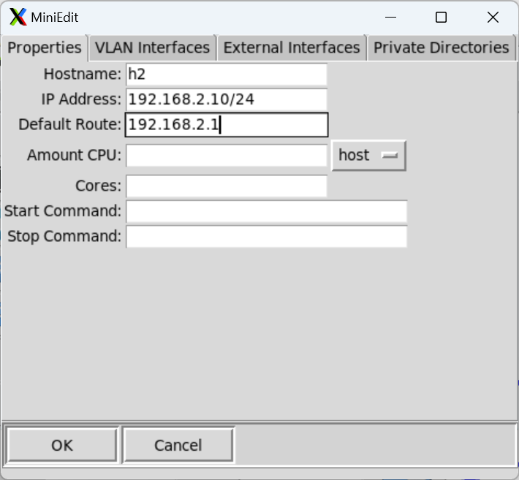

### Verify end-hosts configuration

In this section, you will verify that the IP addresses are assigned according to Table 2. Additionally, you will check routing information.

**Step 1**. Hold right-click on host h1 and select *Terminal*. This opens the terminal of host h1 and allows the execution of commands on that host.

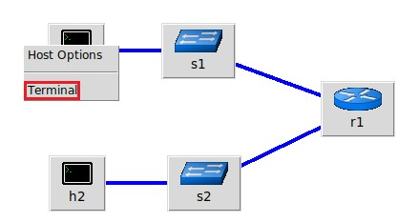

Figure 32. Opening a terminal on host h1.

**Step 2.** In host *h1* terminal, type the command shown below to verify that the IP address was assigned successfully.

You will verify that host *h1* has two interfaces, *h1-eth0* configured with the IP address *192.168.1.10* and the subnet mask 255.255.255.0 and, the loopback interface *lo* configured with the IP address *127.0.0.1*.

ifconfig

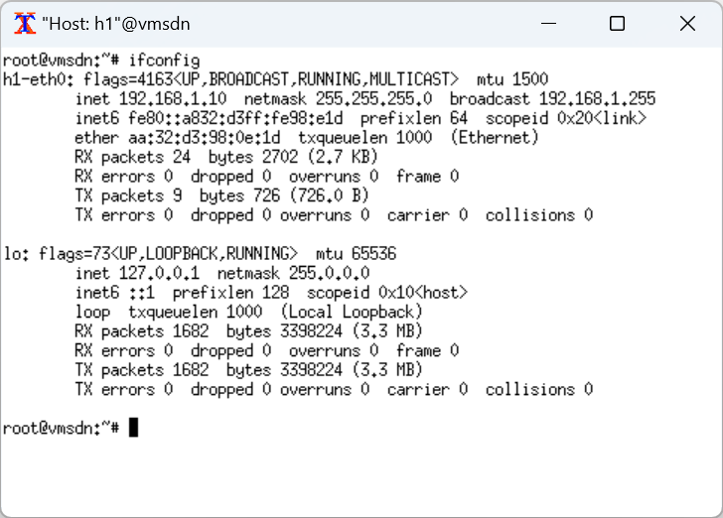

Figure 33. Output of command.

**Step 3**. In host h1 terminal, type the command shown below to verify that the default gateway IP address is 192.168.1.1.

root@admin# route

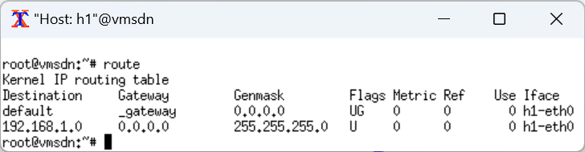

Figure 34. Output of command.

**Step 4**. In order to verify host 2 default route, proceed similarly by repeating from step 1 to step 3 in host h2 terminal. Similar results should be observed.

### Configure router’s interface

**Step 1**. In order to configure router r1, hold right-click on router r1 and select *Terminal*.

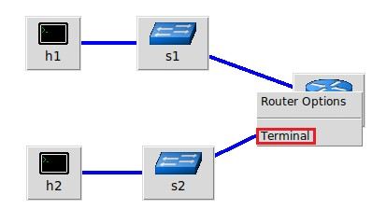

Figure 35. Opening a terminal on router r1.

**Step 2**. In this step, you will start *zebra* daemon, which is a multi-server routing software that provides TCP/IP based routing protocols. The configuration will not be working if you do not enable zebra daemon initially. In order to start the zebra, type the following command:

root@admin:/etc/routers/rl# zebra

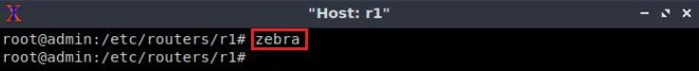

Figure 36. Starting zebra daemon.

**Step 3**. After initializing zebra, vtysh should be started in order to provide all the CLI commands defined by the daemons. To proceed, issue the following command:

root@admin:/etc/routers/rl# vtysh

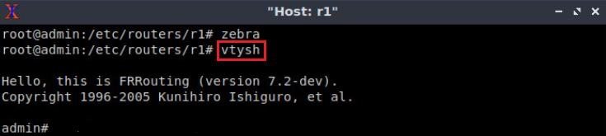

Figure 37. Starting vtysh on router r1.

**Step 4.** Type the following command in the router r1 terminal to enter in configuration mode.

root@admin:/etc/routers/rl# configure terminal

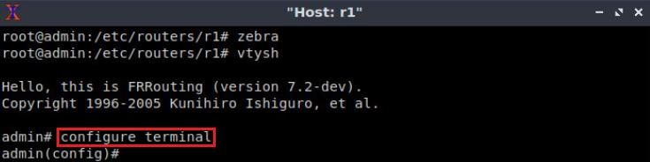

Figure 38. Entering in configuration mode.

**Step 5.** Type the following command in the router r1 terminal to configure interface *r1eth0*.

admin(config)# interface r1-eth0

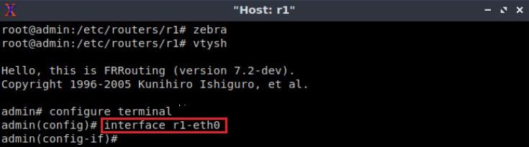

Figure 39. Configuring interface *r1-eth0*.

**Step 6.** Type the following command on router r1 terminal to configure the IP address of the interface *r1-eth0*.

admin(config-if)# ip address 192.168.1.1/24

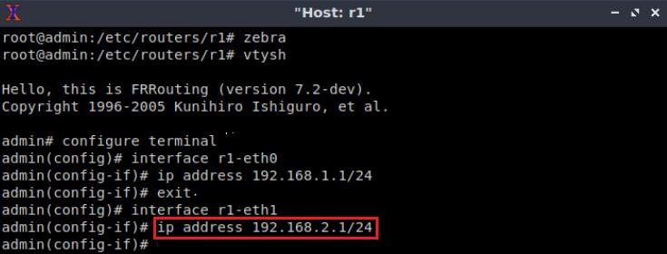

Figure 40. Configuring an IP address to interface *r1-eth0*.

**Step 7.** Type the following command exit from interface *r1-eth0* configuration.

admin(config-if)# exit

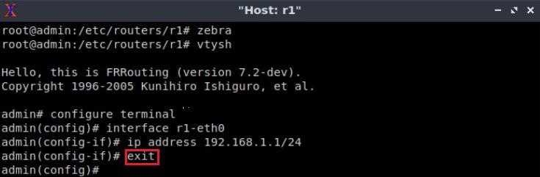

Figure 41. Exiting from configuring interface *r1-eth0*.

**Step 8.** Type the following command on router r1 terminal to configure the interface *r1eth1*.

interface r1-eth1

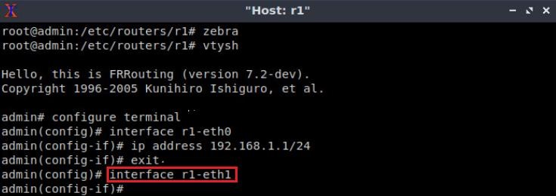

Figure 42. Configuring interface *r1-eth1*.

**Step 9.** Type the following command on router r1 terminal to configure the IP address of the interface *r1-eth1*.

admin(config-if)# ip address 192.168.2.1/24

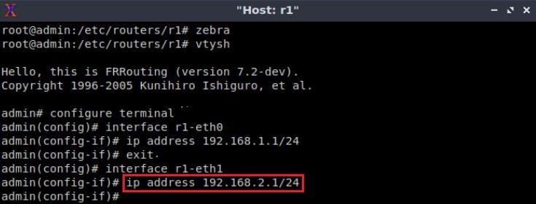

Figure 43. Configuring an IP address to interface *r1-eth1*.

**Step 10.** Type the following command to exit from *r1-eth1* interface configuration.

admin(config-if)# exit

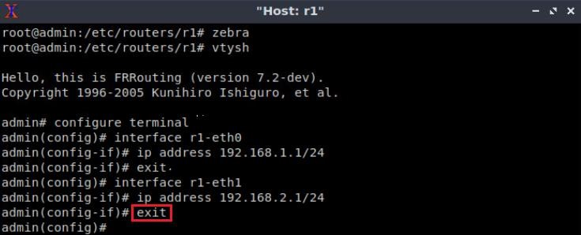

Figure 44. Exiting from configuring interface *r1-eth1*.

### Verify router r1 configuration

**Step 1**. Exit from router r1 configuration mode issuing the following command:

admin(config)# exit

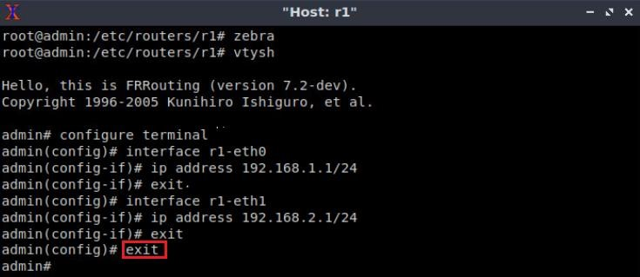

Figure 45. Exiting from configuration mode.

**Step 2.** Type the following command on router r1 terminal to verify the routing information of router r1. It will be showing all the directly connected networks.

admin# show ip route

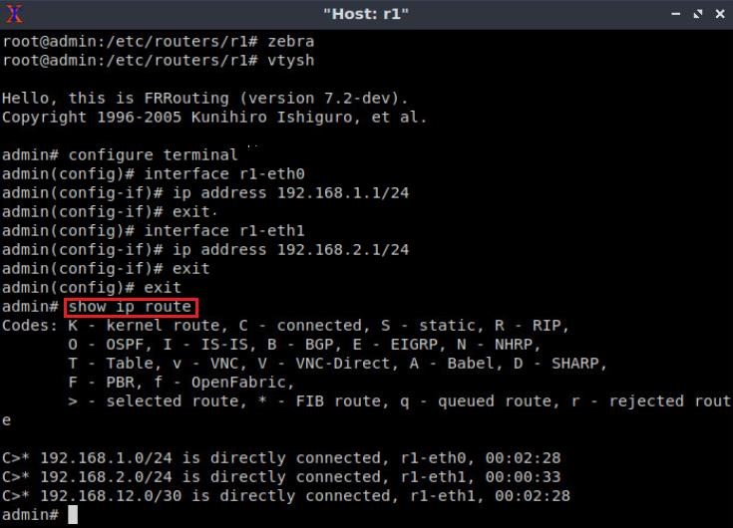

Figure 46. Displaying routing information of router r1.

### Test connectivity between end-hosts

In this section you will run a connectivity test between host h1 and host h2.

**Step 1.** In host h1 terminal type the command shown below.

Notice that according to Table 2, the IP address 192.168.2.10 is assigned to host h2. To stop the test press Ctrl + c

root@admin# ping 192.168.2.10

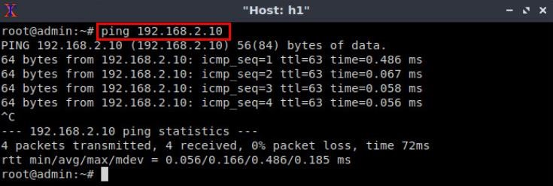

Figure 2.1. Connectivity test between host h1 and host h2.

This concludes this Lab. Stop the emulation and then exit out of MiniEdit and Linux terminal.

# References

1. Mininet walkthrough. [Online]. Available: http://Mininet.org.
2. N. Mckeown, T. Anderson, H. Balakrishnan, G. Parulkar, L. Peterson, J. Rexford, S.
3. Shenker, and J. Turner, “OpenFlow,” ACM SIGCOMM Computer Communication
4. Review, vol. 38, no. 2, p. 69, 2008.
5. J. Esch, “Prolog to, software-defined networking: a comprehensive survey,” Proceedings of the IEEE, vol. 103, no. 1, pp. 10–13, 2015.
6. P. Dordal, “An Introduction to computer networks,”. [Online]. Available: https://intronetworks.cs.luc.edu/.
7. B. Lantz, G. Gee, “*MiniEdit: a simple network editor for Mininet,*” 2013. [Online]. Available: https://github.com/Mininet/Mininet/blob/master/examples.

(Tài liệu lưu hành nội bộ)

-----------------------------------------------